**DATABASE LAB # 14**

**Name: Ahmed Kasteer**

**Roll Number: 20F-0336**

**Section: 4D**

**1:**

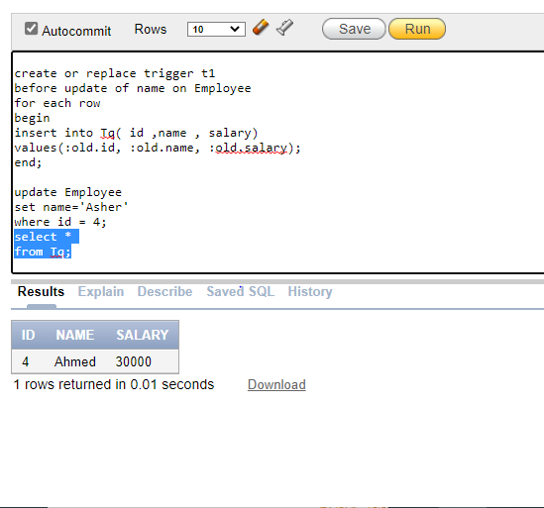

**2:**

create or replace trigger t

before update of name on Employee

for each row

when ( new.salary - old.salary > old.salary*0.1)

declare

begin

dbms_output.put_line( 'old salary' || :old.salary);

dbms_output.put_line( 'new salary' || :new.salary);

dbms_output.put_line( 'new id' || :new.id);

dbms_output.put_line( 'new name'|| :new.name);

end;

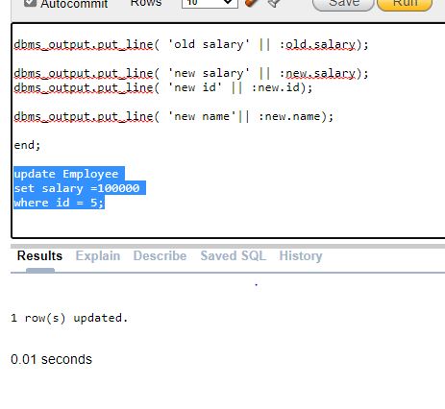

**3:**

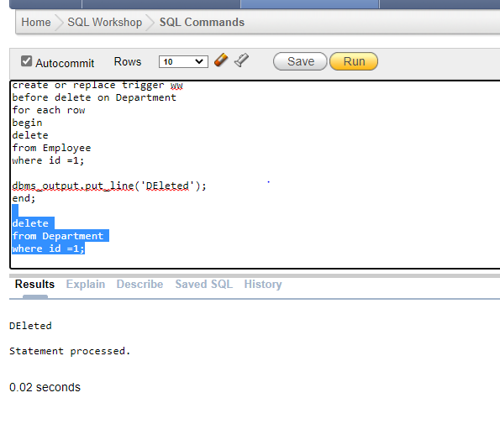

**4:**

create or replace view table_view (

id , salary ,name , d_id , d_name) AS

select Employee.id , Employee.salary , Employee.name , Department.d_id , Department.d_name

from Employee , Department

where Employee.id = Department.d_id;

select *

from table_view;

create or replace trigger tabl

instead of update

on table_view

for each row

begin

update Department

set id= :new.id;

end tabl;

select *

from table_view;

begin

update table_view set id=1

where name like 'Asher';

commit;

end;

